September 2nd, 2025
Downstream Glenn Highway MP 64.7 culvert at 61.73042 N, 148.79616 W observed chum and sockeye presence.
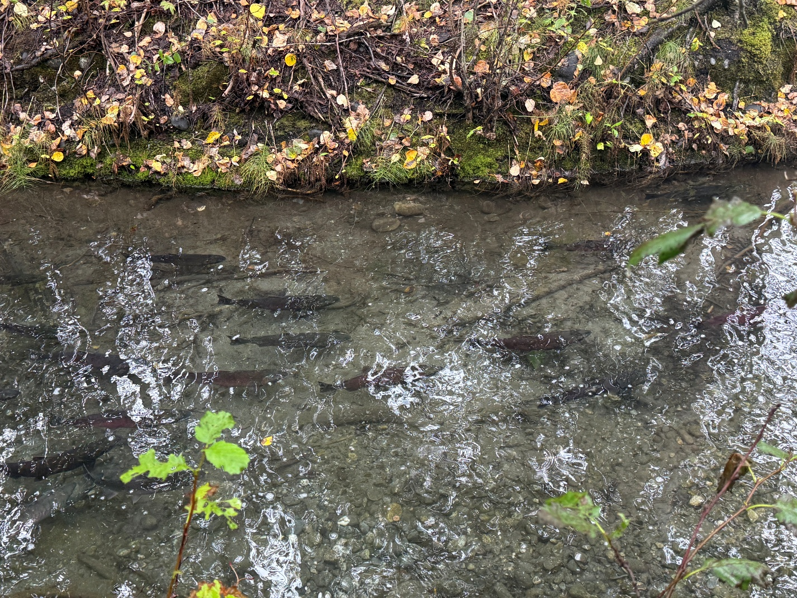
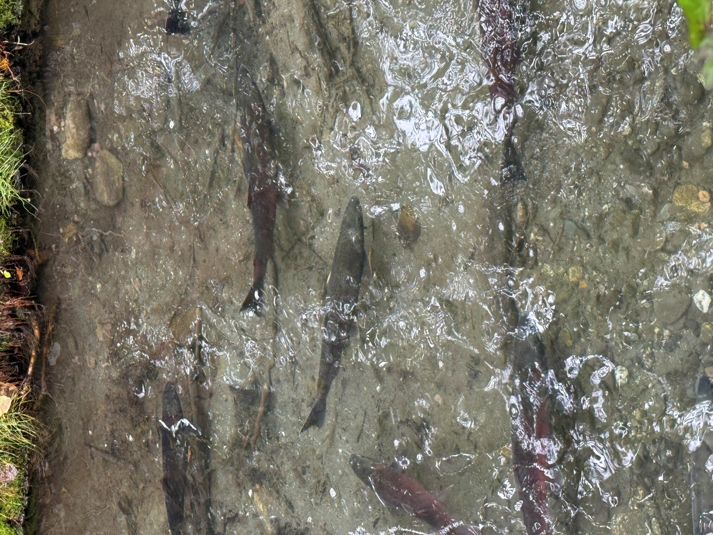
Upstream Glenn Highway MP 64.7 culvert at 61.73127 N, 148.79556 W observed chum presence and sockeye spawning.
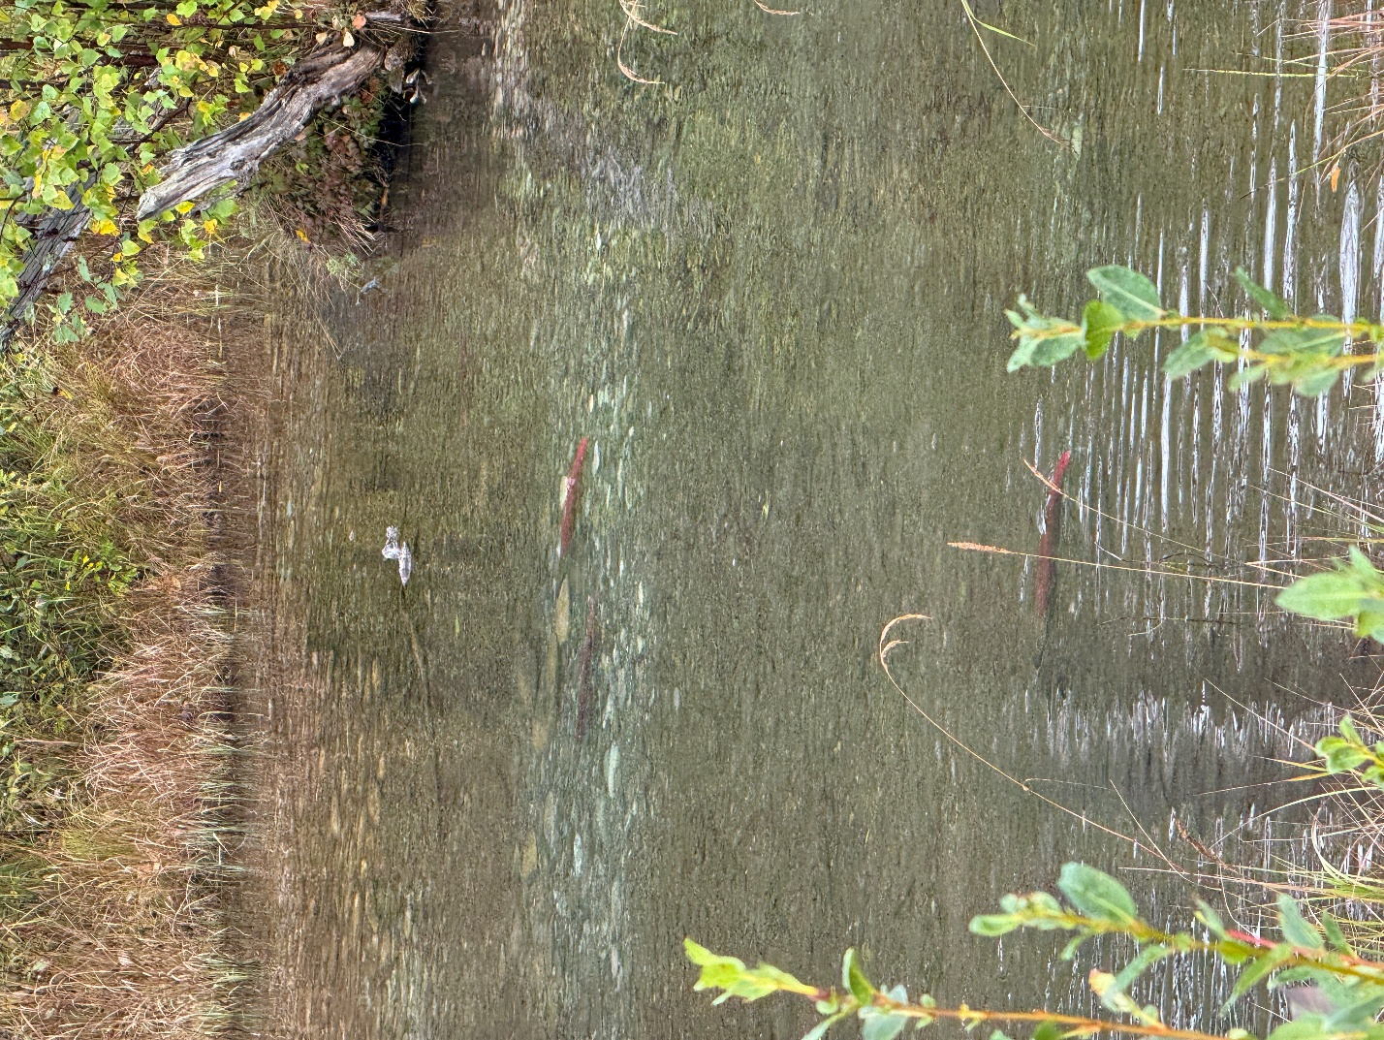
At 61.73471 N, 148.78622 W in a large beaver complex observed sockeye salmon presence and chum salmon spawning.
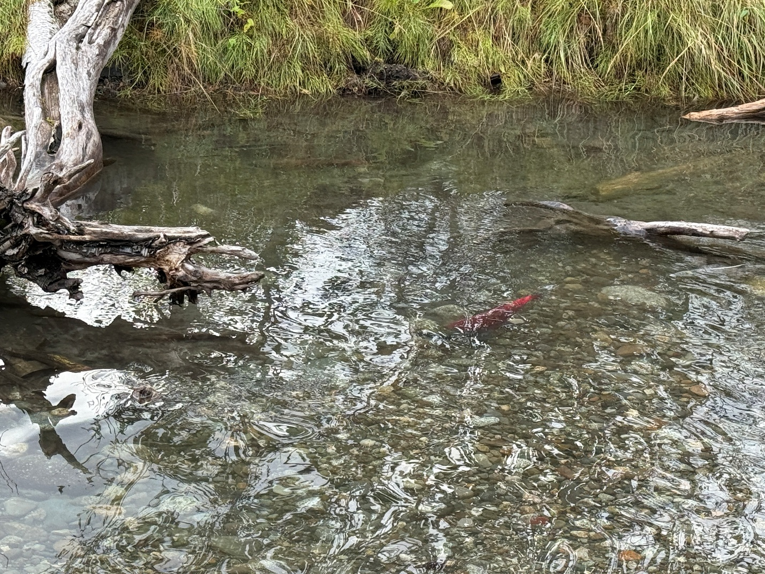
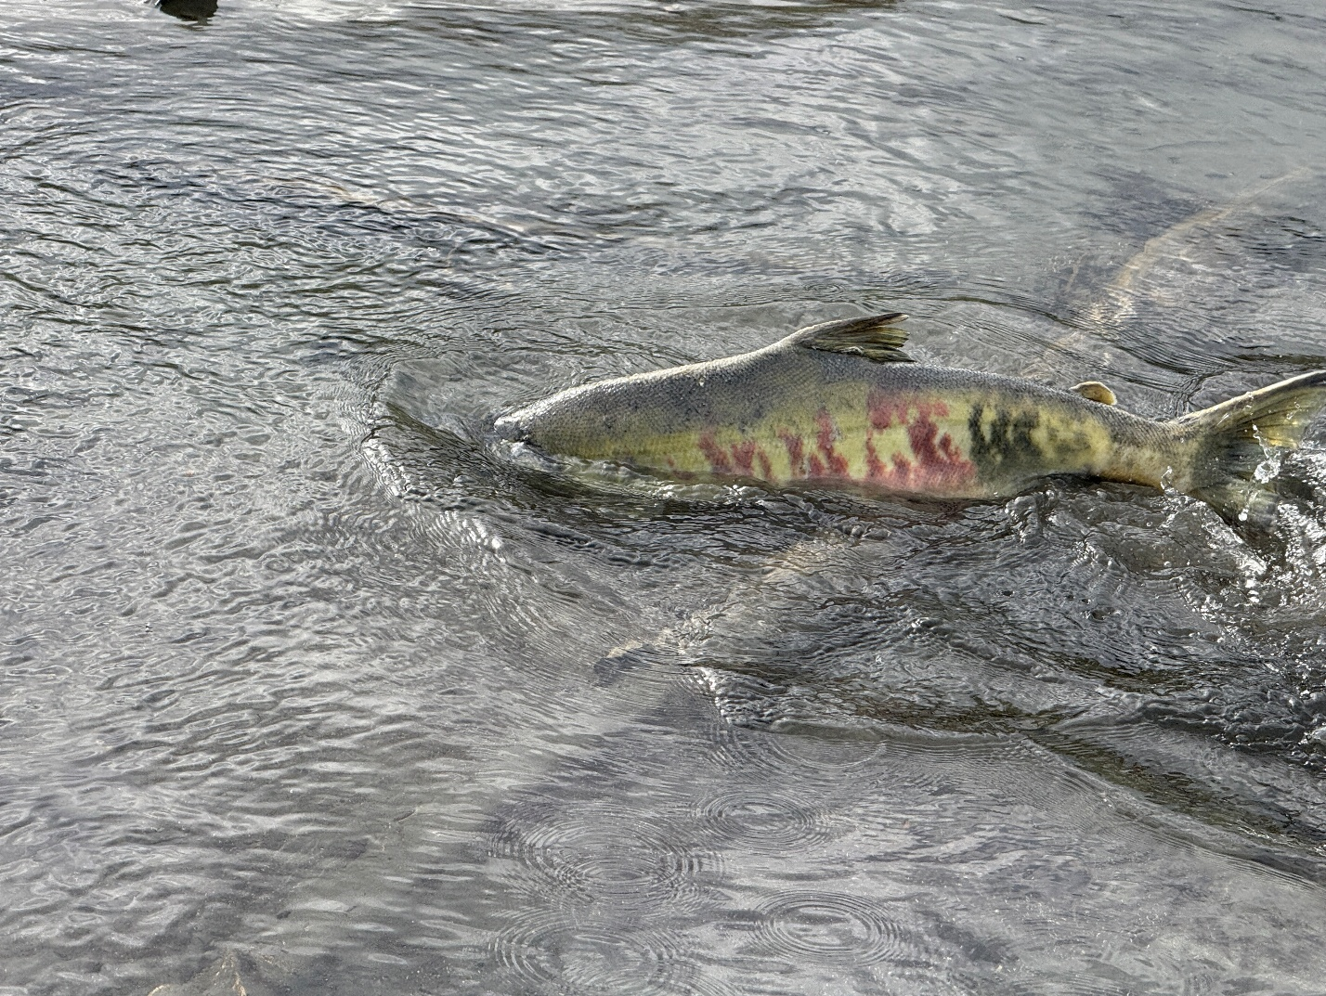
At 61.73492 N, 148.77882, we observed chum spawning and sockeye spawning.
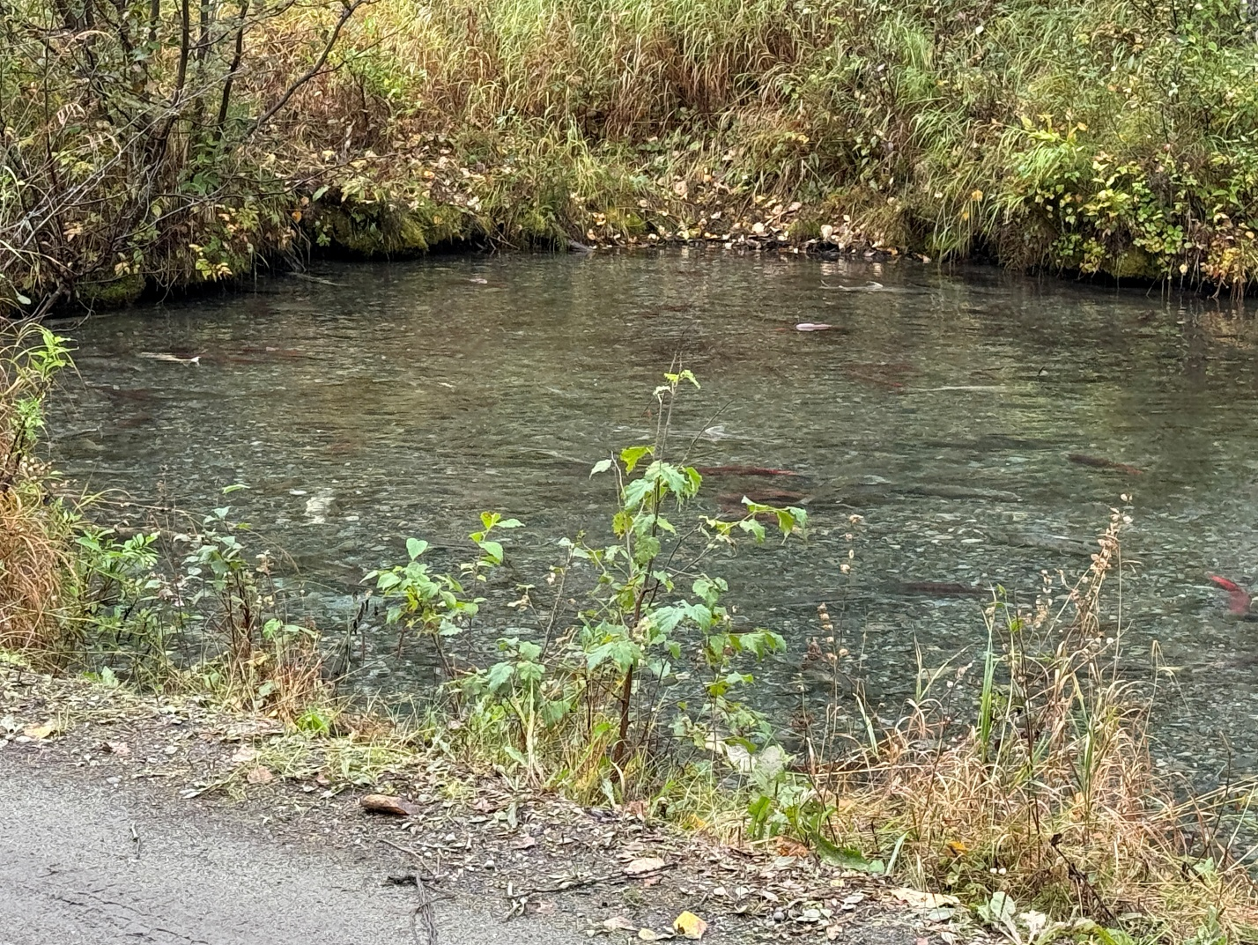
September 3rd, 2025
At 61.73471 N, 148.78622 W we trapped juvenile 28 sockeye and 19 coho salmon. Two coho salmon measured at 125 mm and 80 mm as well as two sockeye salmon measured at 40 mm and 65 mm.
